Name: ___________________________________ Score: ________________

**Reading Clock - Hours**

Read the clock and write the time.

1)

2)

3)

4)

5)

6)

8)

9)

Time: ________________

Time: ________________

Time: ________________

Time: ________________

Time: ________________

Time: ________________

Time: ________________

Time: ________________

Time: ________________

7)

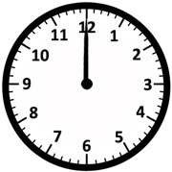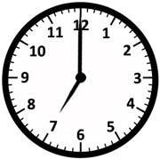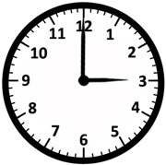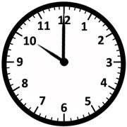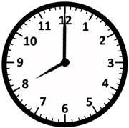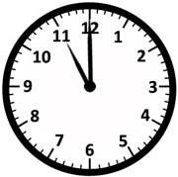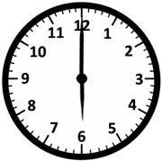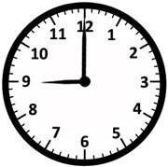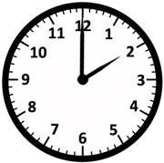

Printable Math Worksheets @ www.mathworksheets4kids.com